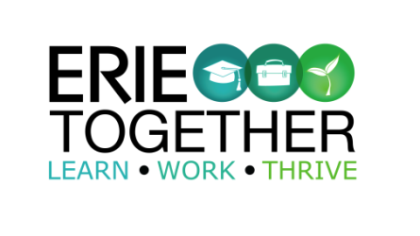

* Attend the 2 hour *Bridges Out Of Poverty* training on the curriculum and needs of the community
* Be prepared to mentor someone in poverty through the Getting Ahead program should you decide to do so.

**TRAINING EVENT**

**BRIDGES OUT OF POVERTY**

**gETTING**

**aHEAD**

Thursday

**July 23, 2020**

**GECAC**

Via Zoom Technology

**5:00 pm-7:00 pm**

Is a 2 hour training based on strategies from the Bridges Out Of Poverty community support program authored by Dr. Ruby Payne Ph.D. This training introduces a framework for understanding poverty, and provides powerful tools, designed to help you more effectively serve those who live or have lived in poverty. The presentation enables us to reframe our own thinking in order to build and maintain relationships with people who are different than us.

**\*Registration is required**

***As a participant you will:***

For more information, please contact:

Maureen Kennedy-Fink Program Coordinator

(814) 812-2359 ● mfink@gecac.org

www.erietogether.org/getting-ahead