Our Classes

Getting Ahead in a Just Gettin’ by World
Do you feel stuck and not getting ahead in life? This program may be for you! As a participant, you will learn about your community and assess your needs. Through a virtual “round table” discussion, held weekly, you can discuss the challenges you face in moving ahead. There are 10 modules and each week a different topic is discussed. This helps you take an in-depth assessment of your life so you can begin to make changes to get “unstuck”. Come be part of the solution— you have a voice!
For more information contact:
Maureen Kennedy-Fink
Getting Ahead Coordinator
814-459-4581 ext. 422
mfink@gecac.org
Location
Greater Erie
Community Action Committee
18 West 9th Street
Erie, PA 16501

Due to COVID-19, GECAC is using the online platform Zoom.
A link will be sent once you are signed up
814-459-4581

www.gecac.org

www.facebook.com/GECACErie/

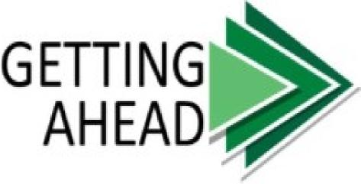
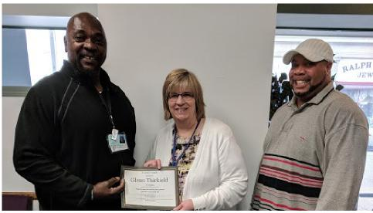
Research
Assess
Future

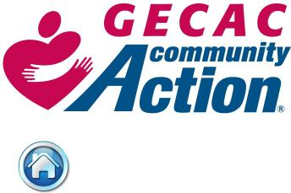
www.gecac.org

What is Getting Ahead?

Research
- Due to COVID-19, classes are held via Zoom Technologies 10 weeks in length, once a week class.
- Research the impact of poverty in the community
- Research about various “class” types and the hidden rules behind them
- Research your own life and what areas do you need to address such as housing, debt, health and employment to “Get Ahead” instead of “Getting By”
Assess
- Participants will make an in depth evaluation of their current situation
- Learn how to build resources within the community
- Connect with community leaders
- Develop friendships and relationships along the way
- Be matched with a Mentor to have added support as you complete your goals
.
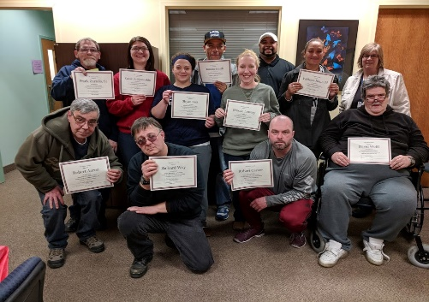
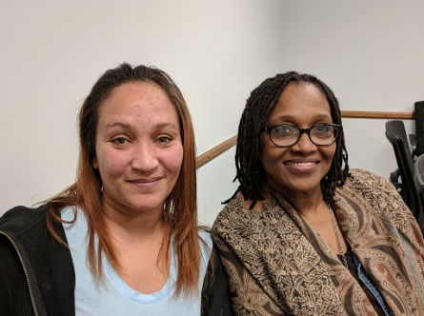
Future
- Participants will begin to seek changes within themselves to develop their “future story”
- Will develop at least 3 short term or long term goals
- Will be matched with a Mentor who will be an added support and encouragement
- Stipends and incentives can be provided for participation and attendance.

