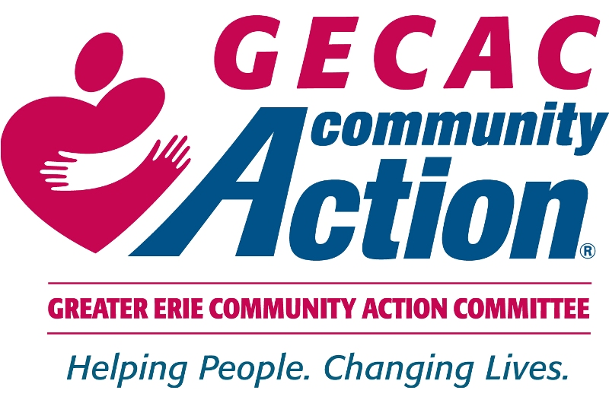

Tell the Erie County Council to Continue

Funding Your Senior Center!

Dear Senior Center Member,

I am writing to you about an urgent matter. Our Erie County government has proposed to eliminate significant GECAC funds that go to older adult services from its 2023 budget. This includes funding for your Senior Center.

You have an opportunity to voice your opinion to the Erie County Council members before they vote to remove this support. Please tell your local council member that this vital funding and your senior center are important to you and your community.

* They propose to **eliminate $462,871** in funding provided to GECAC Area Agency on Aging for senior services.
* These dollars support Senior Community Center activities for **930 seniors** throughout Erie County.
* This funding provides **lunch to** **628 seniors** (28,191 lunches per year) at senior centers in Erie County.
* These funds also provide **Meals on Wheels to** **629** seniors (107,419 meals per year).
* County Council will vote on the budget on **November 23, 2022**.

What can you do? Make your voice heard!

* Call, email, or write your local council member and tell them to act now to protect the funding for seniors throughout Erie County.
* Attend the next council meeting. This meeting is open to the public. We are asking all senior center members and your families to attend this crucial meeting. We must ask County Council to continue funding our senior centers. We called County Council and these are the tentative council meeting dates:

https://eriecountypa.gov/departments/county-council/agendas-and-meetings/meeting-schedule/

Date: Tuesday, November 1

Time: 4:30 PM

Location: Erie County Courthouse

140 W. Sixth Street, Erie PA

Date: Thursday, November 17

Time: 3:30 PM

Location: Erie County Courthouse

140 W. Sixth Street, Erie PA

GECAC’s Board of Directors and staff are doing all they can to stop this injustice. Your voice will make a difference. Help us fight for your senior center and all of the services provided by the GECAC Area Agency on Aging.

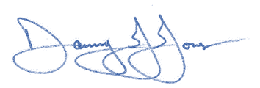Sincerely,

Danny J. Jones

Chief Executive Officer

**How to Contact Your Elected County Council Official**

It is best to contact the County Council member that serves the area in which you live (District).

*Send letters to:*

**Erie County Council**  
140 West Sixth Street  
Room 114  
Erie, PA 16501

*Call or email:*

**Erie West Senior Center**

**Terry M. Scutella**, Millcreek Township (District 1)

Phone: [814-451-6303](tel:814-451-6303) Email: [tscutella@eriecountypa.gov](mailto:tscutella@eriecountypa.gov)

**Mary Rennie**, Erie City & Millcreek Township (District 3)

Phone: [814-451-6303](tel:814-451-6303) Email: [mrennie@eriecountypa.gov](mailto:mrennie@eriecountypa.gov)

**R. Benjamin Wiley Central City Senior Center**

**André R. Horton**, Erie City (District 2)

Phone: [814-451-6303](tel:814-451-6303) Email: [ahorton@eriecountypa.gov](mailto:ahorton@eriecountypa.gov)

**Jim Winarski,** Erie City, Wesleyville Borough & Millcreek Township (District 4)

Phone: [814-451-6303](tel:814-451-6303) Email: [jwinarski@eriecountypa.gov](mailto:jwinarski@eriecountypa.gov)

**North East Senior Center**

**Brian Shank,** Harborcreek, North East, Summit & Wesleyville Borough (District 5)

Phone: [814-451-6303](tel:814-451-6303) Email: [bshank@eriecountypa.gov](mailto:bshank@eriecountypa.gov)

**Union City and Corry Senior Centers**

**Charlie Bayle,** Corry, Union City, Edinboro, Waterford & Wattsburg (District 6)

Phone: [814-451-6303](tel:814-451-6303)  Email: [cbayle@eriecountypa.gov](mailto:cbayle@eriecountypa.gov)

**Northwestern and Tri-Boro Senior Centers**

**Ellen Schauerman,** Albion, Girard, Lake City, Fairview & McKean (District 7)

Phone: [814-451-6303](tel:814-451-6303) Email: [eschauerman@eriecountypa.gov](mailto:eschauerman@eriecountypa.gov)

**Tips for What to Say to Your District’s Council Member**

1. Identify yourself and the senior center you attend. Tell them that you are a voter.
2. State that you are opposed to the cutting of funding for your senior center and all of the GECAC Area Agency on Aging services.
3. Be personal: Let your council member know why your senior center means so much to you.
4. Explain how losing your senior center’s services will impact you.
5. Urge your council member to keep funding for senior centers in the 2023 budget.