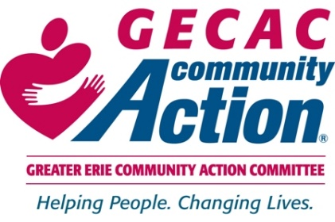
Op-Ed: County Budget Cuts Will Hurt Most Vulnerable in Our Community

By Danny Jones, Chief Executive Officer

Erie County Executive, Brenton Davis, has proposed to eliminate nearly $1 million from the county’s 2023 budget that funds vital services for Erie County’s older adults, youth, and underemployed individuals. County Council will be voting on this crucial funding on November 23rd.

The proposed budget eliminates $992,000 in services provided by the Greater Erie Community Action Committee (GECAC). Here are the problems that the proposed cuts create:

- $463,000 will be cut from GECAC’s Area Agency on Aging (AAA). These services play a critical role in helping older adults remain in their homes and communities for as long as possible. Services that would be impacted include Meals on Wheels, nine senior centers, in-home health, and personal care services as well as our AmeriCorps Seniors programs—Retired Senior Volunteer Program and Foster Grandparents. These funding cuts would impact 10,000 seniors in Erie County. Not only would older adults be impacted, but schools and organizations would lose 170,000 hours of volunteer time that our 400 AmeriCorps Seniors provide. We saw the dire effects that social isolation had on older adults during the COVID-19 pandemic. Many seniors, especially low-income older adults, had no visitors, no way to get food, and no one to monitor their physical or mental health. We are just beginning to turn around the adverse effects that the last few years have inflicted on our elderly population. Cutting funding for senior services will make the long-term prognosis of our seniors disastrous for short-term gain.

- If the county cuts funding for aging services, GECAC will lose an additional $430,000 in matching funds from the federal government. In total, we will have to eliminate $893,000 worth of vital services for older adults throughout Erie County at a time when seniors need more services, not less.

- The GED Testing Center and Adult Basic Education would have $270,000 of their funding cut, eliminating both programs which combined serve 225 adult students each year. GECAC operates the only GED Testing site in Erie County. Our residents would have to travel to Warren or Oil City multiple times to take their four-part GED exam. This would be an extreme hardship for people trying to better their lives for their families. Limited basic skills are a widespread problem among thousands of adults in Erie County. Low reading and math skills impact employability and earnings. Nearly 10% of adults do not have a high school diploma. Adults without a high school diploma are more than 2x as likely to live in poverty as high school graduates.
MORE
- The budget proposes to eliminate all funding from the Summer Jobs and More program (Summer JAM) totaling $263,000. Our youth employment program addresses a broad range of vocational skills. Summer JAM helps youth throughout Erie County gain the abilities and training necessary to be successful in transitioning to adulthood and careers. Summer JAM has been a successful partnership with local businesses, organizations, Erie County Gaming Revenue Authority, and the Erie County government to address the needs of youth in our communities. Students residing throughout 11 school districts participated this year. GECAC has been providing summer employment programs for 50 years. This recent employment program was created because the community rallied and asked our government to provide funding for Summer JAM. This program is also critical to small businesses looking for summer employees. Katherine Bowes, owner of The Buzz Cafe in Union City said “It’s the young workers and the Summer JAM program that enable small local businesses to grow and thrive, equipping them with the staffing needed that the business may not otherwise have the ability to afford.” (Chloe Forbes/The Corry Journal)

The impact of these budget cuts will have a detrimental impact on people all across Erie County. GECAC is speaking with one voice—representing seniors on fixed incomes, at-risk youth, and parents trying to better their lives for their families—asking County Council to act decisively and return funding for GECAC’s services in the 2023 budget.

###

